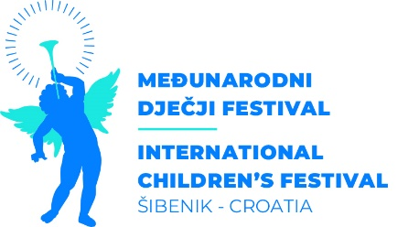

**TERMS AND CONDITIONS OF THE 65th INTERNATIONAL CHILDREN'S FESTIVAL (ICF) Šibenik - Croatia**

1. **How to apply for performances:**

The application process consists of filling in the submission form and rooming list that can be found on the ICF official website [www.mdf-sibenik.com](http://www.mdf-sibenik.com).

1. **Submissions should be sent to:**
   * + by e-mailing [tajnistvo@hnksi.hr](mailto:tajnistvo@hnksi.hr) and [production@mdf-sibenik.com](mailto:production@mdf-sibenik.com)
     + or by post

Croatian National Theatre in Šibenik

for the 65th International Children's Festival Šibenik - Croatia

Kralja Zvonimira 1

22 000 Šibenik

Republic of Croatia

1. **All programmes from abroad should be submitted no later than December 20th 2024.**
2. **The Festival bears the costs of accomodation (full board) and fee for foreign participants of the 65th ICF Šibenik – Croatia.**

Festival participants bear the costs of transport to Šibenik and from Šibenik to their seat.

1. **Deadline for contacting the selected companies/artists is February 1st 2025**

Due to the large number of submissions, only the selected companies will be contacted. If you haven’t heard from us, we thank you for your interest regarding the International Children`s Festival Šibenik Croatia and we are gladly waiting for you for a new selection session for the editions to come.